**RESUME**

**Khushi Rani**

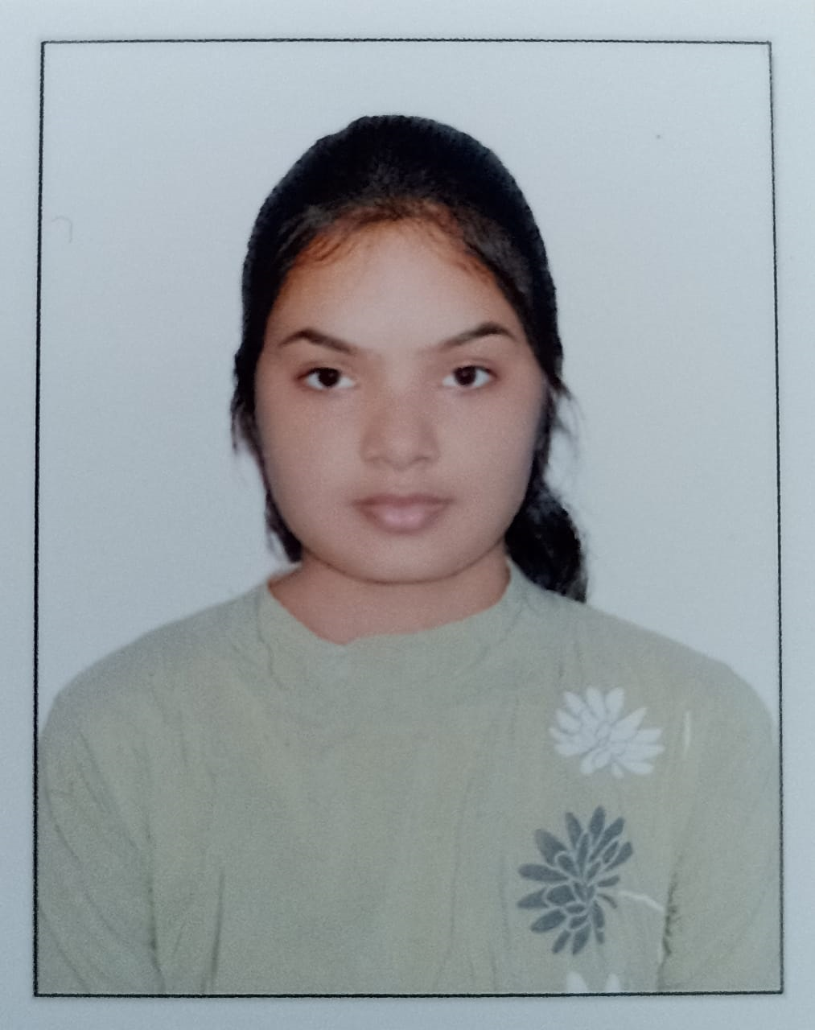

**Adityapur**

**Dist- Seraikela Kharsawan**

**Jharkhand**

**831013**

**Email Id** – [ranikhushi2005@gmail.com](mailto:ranikhushi2005@gmail.com)

**Mobile No**. – 9142864752

**Career Objective:**

To secure an internship in the field of Computer Science and Engineering to apply and enhance my academic knowledge while gaining practical experience in a professional setting. Eager to learn and grow in a real-world professional environment.

**My Strength:**

* Hardworking
* Sincerity & Punctuality
* Positive attitude
* Quick learner
* Self motivator

**Academic career:**

|  |  |  |  |
| --- | --- | --- | --- |
| **Education** | **Board/University** | **Passing year** | **score** |
| Bachelor of Technology in Computer Science and Engineering | ARKA JAIN UNIVERSITY | persuing | 8.87 CGPA  (upto 2nd sem) |
| Intermediate | CBSE | 2022 | 84% |
| Matriculation | CBSE | 2020 | 88% |

**Technical Skills:**

* **Programming Languages** : C, JAVA, Python
* Familiar with Window Operating System
* Have good knowledge on MS Word, MS Excel, MS Power Point

**Soft skills**

* Team work
* Problem solving

**University Involvement:**

**Core Team Member, Google Developer Student Clubs (GDSC-AJU)**

**Arka Jain University**

**[August-2023] - Present**

* Actively contribute to the planning and execution of technical and skill-building events.
* Collaborate with team members to foster a learning community within the university.

**Certifications:**

* **Google Cloud Study Jam**
  + Completed comprehensive training in Google Cloud Platform (GCP) technologies through a Study Jam program organized by Google.
  + Developed practical skills in cloud computing, including hands-on experience with GCP services such as Compute Engine, Kubernetes Engine, and BigQuery.

**Personal Details:**

|  |  |
| --- | --- |
| Name | Khushi Rani |
| Mother’s Name | Mamta Kumari Gupta |
| Father’s Name | Nityanand Saw |
| Gender | Female |
| Blood Group | O+ |
| Marital Status | Single |
| Language Known | Hindi, English |
| Date of Birth | 27-09-2004 |

**Declaration:**

I do hereby declare that all the statements and data given above are true to my knowledge and belief.

Signature:

Khushi Rani

Date: 30/12/2023

Place: Jamshedpur